**INTRODUCTION**

A virtual assistant can be used to control gadgets like laptops or PCs. An application programme known as a virtual assistant can do tasks for users by comprehending natural language and voice commands. Only verbal communication is possible between users and their assistant, who may then use voice commands to control media playback, home automation devices, and other common tasks like email, to-do lists, opening or closing applications, sending messages through Whatsapp from anyone These are the additional speech Assistant variants

:

• Intelligent Personal Assistant

• Automated Personal Assistant

• Virtual Digital Assistants

• Chatbot

Virtual assistants are now incredibly helpful to people. It makes life easier for people to use voice commands to control laptops or PCs. The virtual helper requires less time. By utilizing virtual assistants, businesses may save time and contribute to other tasks. Virtual volunteers and cloud-based programs typically require internet-connected devices. The flexibility is to only hire the services they require is provided by the virtual assistant. Start with Python's fundamentals to building a computer-based virtual assistant device to provide the output voice and the micro phone as an input device to receive virtual voice commands from the user. Many technologies, which includes voice recognition, analysis of voice, and processing of language, are combined in this process. Natural Processing Language (NPL) is mainly used by virtual assistants to translate text or input of voice into actionable commands. When a user gives an instruction to perform a task from a personal virtual helper, the user's aural commands are converted into digital signals. A variety of services can be provided by virtual assistants, including as the following. Virtual assistants are mostly focused on their tasks. virtual assistants’ ability is to understand and obey commands. These are computer programs that can do jobs assigned by customers and understand oral and written commands.

.Virtual assistants are capable of understanding spoken language and responding with synthetic voices. There are several voice assistants available, including Siri for Apple TV remotes, Cortana for Windows 10, Google Assistant for Pixel XL smartphones, Alexa for Raspberry Pi-powered smart speakers, and Siri for Apple TV remotes. Like all other virtual assistants, we also developed one for Windows. For this project, we make use of artificial intelligence technology. since python have has quality main libraries we use Python as a programming language. This software uses the speaker as an output

• Showing of weather conditions.

• Scheduling the appointments.

• Making traveling arrangements.

• Play music, cinemas, etc.

• Show date-time.

• Manage emails.

• Open applications.

**METHODOLOGY:**

Virtual assistants employ NLP to convert user-spoken or written input into actionable commands. When personal assistant was asked to perform a task by a user, these natural language audio signals are converted into executable commands or digital data that may be analysed by the software. This data is then contrasted with software data to provide an acceptable response. By using virtual assistants, you can control devices with your own commands. We employ a few programmes to generate these virtual assistants

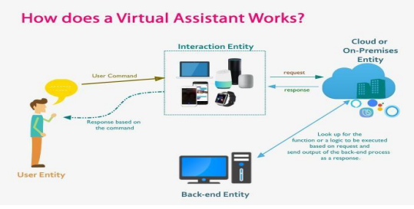

**1) Speech recognition:**

The technology uses online speech recognition of Google’s algorithm in order to change spoken input into text. Customers can use this to speak into a microphone; the audio is briefly kept in the system before being forwarded to the Google Cloud enabling voice recognition; and in exchange, they can obtain text from a specific corpus organized on a computer network server at the information centre. This same text is sent to the virtual voice assistant software and received.

**2) The Python Backend:**

The total programme was written in Python Backend. This Python backend converts the voice input from the speech recognition module into output before deciding whether the supplied instruction is an API Call, Context Extraction, or System call. This response is then sent on to the output source that we asked at the time when we really needed it.

**3) API calls:**

An API, or the Application Programming Interface, is a form of software that makes it easier for two separate applications to communicate with each other. To tell it another way, API serves as a message relay, transferring the user's request to the provider and then returning it together or both of them with the provider's or giver’s response hence.

**4) Content Extraction:**

By using context extraction, structured data may be automatically extracted from unstructured or partially structured papers that computers can read. In this activity, texts written in human languages are processed using natural language processing. One way to define content extraction is automatic actions and extractions, such as automatic annotation and content extraction from the various number of pictures, or videos, and many other audio files too.

**5) System Calls:**

When a system call is made, the kernel of the operating system is queried programmatically by a computer program. These services might be connected to the hardware functions, such as accessing a hard drive, initiating and managing new processes, or engaging with the process scheduling. It will provide an essential interface between the procedure and the operating system.

**6) Text-to-Speech:**

Text-to-Speech is essentially converted into speech from user-provided. To put it another way, a TTS Engine converts written text into phonetic representation, which is then converted into waveforms, producing sound. TTS has developed considerably, and third-party publishers are now providing TTS in a very wide range of varied languages.

**MODELING AND ANALYSIS**

Mike executes the instruction given by the stoner. This will be a basic need like data transmission or running internal computer lines. This is a qualitative empirical study, and the exemplifications from the literature indicated above are read and verified for accuracy. In order to detect fads and a deep familiarity with voice assistants, tests are created by programmers working in combination with books and other resources. development of technique of the abecedarian of the voice adjunct. Voice recognition is used to transform the spoken input to text. This textbook is additionally sent to the electronic device, which studies the personality of the command and selects the suitable script for trial. A speech recognition system might rapidly become unreliable due to background noise. This is due to the fact that it is unable to distinguish between your voice and other sounds that are in the area that it "hears," like a dog barking or a helicopter flying overhead. The masterminds should programme the device with that capability; they learn about the ambient noises and "tell" the devices to filter those out. Since people naturally change their voice pitch to compensate for noisy environments, speech recognition algorithms are typically sensitive to these pitch shifts and can adapt as necessary based on these pitches.

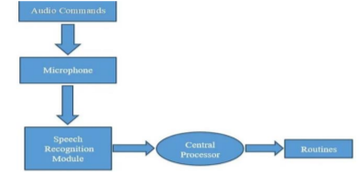

**DETAILED WORK**

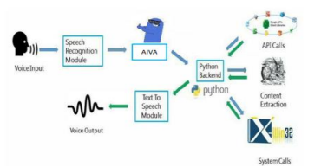

A language recognition system uses an online speech recognition algorithm of Google's to translate spoken input into text. The microphone's recorded voice is momentarily kept by the system and sent to that google for speech recognition. The specific corpora formed on the computer network at the data centre are where the speech input is sourced from. Reverse Python Additionally, the Python backend of the speech recognition module can determine whether a voice affair or command is an API choice, an environment birth, or an administrator decision instruction. It's difficult for the Django backend to convey the circumstance to the stoner in this case. calls made via an API (operation programming interface). An API may operate as a software mediator to allow two activities to communicate with one another. To put it another way, an API is the runner who forwards your request to the provider you are requesting it from and then forwards you the outcome. Context Birth Environment Birth (CE) is a method for automatically extract structured data from the machine-readable texts that are either completely or partially unstructured. The majority of the time, this work considers how textbooks written in dead languages are digested by recommending natural language processing (NLP). Recent advancements in the processing of multimedia documents, such automatic reflection and content synthesis from images, sounds, and videotapes, could be seen as the outcomes of an environment birth check. Telephone calls Administrator decision instruction is the term used in computers to describe the programmed request for a service from the operating system's kernel made by a computer infection. this might entail interacting with core kernel services like process planning, creating and running backward processes, and tackling-related services (for example, breaking through a hard disc drive). System calls serve as a crucial interface between both processes and the Zilchs. Text-to-speech technology The phrase "text-to-speech" (TTS) refers to how rigid computers are when it comes to reading text aloud. An automated TTS system converts a summary into a sound representation, which is then converted into waveforms that can be heard as sound. Third-party publishers offer TTS machines with a variety of languages, dialects, and specialised vocabularies upon request.

**SYSTEM ARCHITECTURE:**

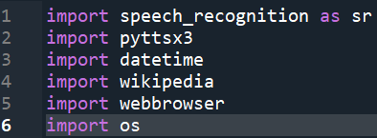

**1) Speech Recognition:**

Voice/Speech recognition is the ability of machine to comprehend human speech. In our project, we're utilizing Python for creating software that can be used to command machines to do things. Installing the Pyaudio Python module is necessary to recognize voice instructions. Using the pip download Pyaudio which is very crucial command, Pyaudio may be installed.

**2)Date Time:**

This date and time package shows the date and also time and this date time comes with Python.

**3)Wikipedia:**

Because Wikipedia is a great and vast source of knowledge, we have used the Wikipedia module in our project to access more pieces of information from Wikipedia. just like geeks for geeks or javatpoint and many more sources that are found in the network

By Using pip install the Wikipedia module to install the Wikipedia module.

**4)Web browser:**

A web Browser is used to work on Web Searches This Web Browser module comes built-in.

.

**5)OS:**

OS of python module are the tools for communication with the operating system. OS is included in the basic utility modules for Python. Using functionality that is dependent on the operating system which will be only made possible by this Operating System module.

**EXPERIMENTATION**

**Implementation of code for Virtual Speech Recognition:**

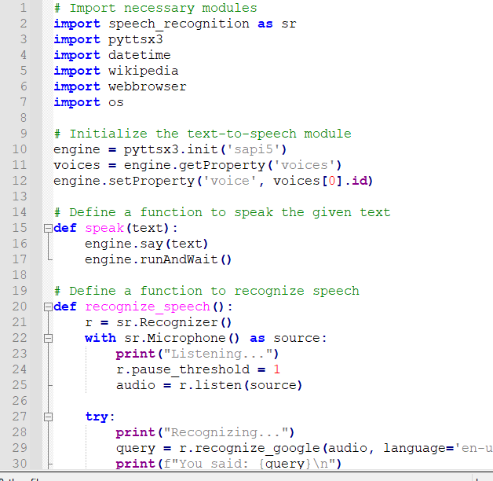

.

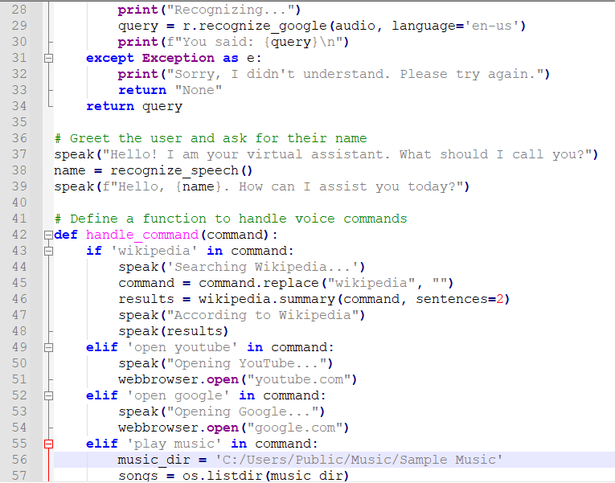

**RESULT**

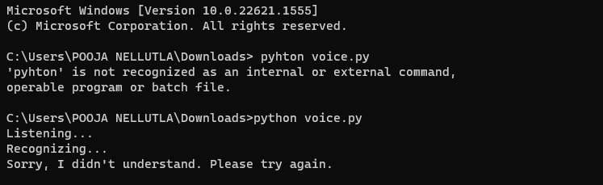

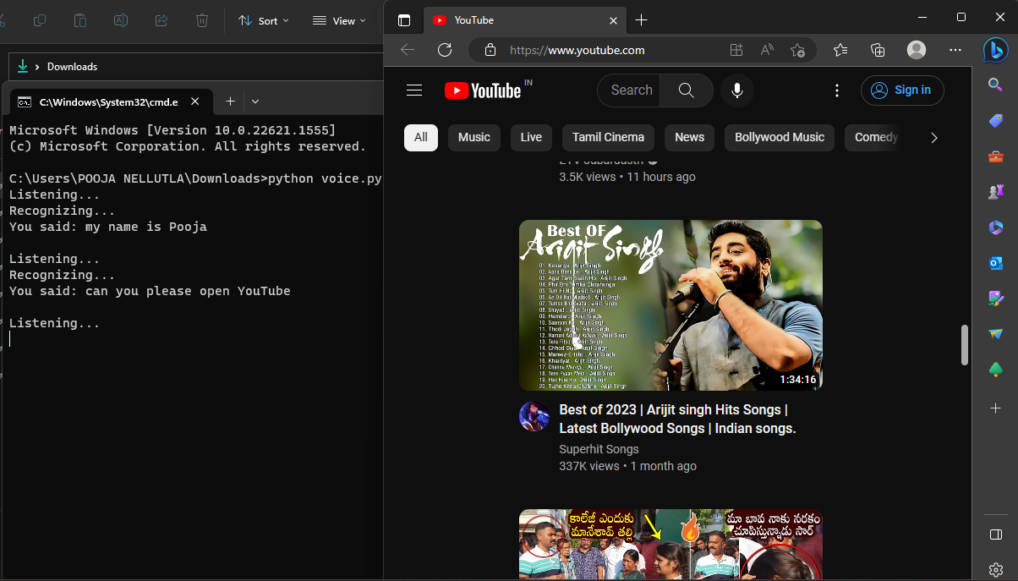

Utilising a virtual assistant saves time. A voice assistant is software that can execute tasks and follow instructions from the customer. Virtual assistants use NLP to matching user voice or text input with actionable orders. With the aid of a virtual assistant, you can autonomously handle gadgets like laptops and PCs. It saves time since it moves quickly. Your virtual assistant is always there to you and is able to react swiftly to changing needs because they work for you during certain hours. You will have access to a virtual assistant, who can also help your family and coworkers if their hectic schedule permits, if they have time..

**OUTPUT:**

In this, we developed a voice/speech assistant that, in exchange for user commands, can flawlessly carry out any task. More capabilities have been added, including the ability to ignore background noise and hear only the user's speech. Because of its modular structure, this project is more flexible and easier to understand. The program's functionality can be expanded without degrading it. The code was created by use of the VS Code Integrated Development Environment (IDE), and all of the necessary packages for the Python programming language have been installed. We used Python 3.x for this virtual speech recognition project, and the environment provided the data for the various and large amounts of these different noises as well.

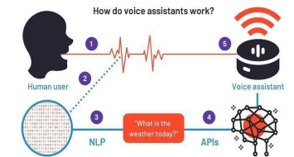

**CONCLUSION:**

In this post, we discussed how to use Python to make a Windows personal assistant. Virtual assistants make life easier for people. the flexibility to merely employ a virtual assistant for the tasks they need. Like Alexa, Cortana, Siri, and Google Assistant, we also construct virtual assistants for all Windows versions using Python. For this project, we're using artificial intelligence technology. Virtual personal assistants are a useful tool for organizing and managing your calendar. Virtual personal assistants are more dependent than real personal assistants since they are more mobile, reliable, and always accessible. In addition to taking directions, our virtual assistant will get to know you better and will provide you with more suggestions.